Project Update – January 16, 2009

Prepared by:
Vikas Garg
Yasin Khan
Shirley Lu
Tim Roberts
Yi Fan Tang
Wesley Tillu

Prepared for:
Dr. Paul Thurston
Agamas Capital Management

Advisors:
Dr. David Matteson
Dr. David Ruppert

Analysis Methodology

- Plots of original and first-differenced OFHEO state-level quarterly data
  - Reasoning
    - Unbiased investigation of original process
    - No statistical assumptions
    - Good reference documentation
  - Plots/Charts
    - TS Original Time Series
    - ACF of Original
    - TS First Difference
    - ACF First Difference
    - PACF First Difference
    - EACF First Difference

- Model Type and Order Determination
  - Plots (ACF/PACF/EACF)
  - AIC and BIC

- Model Fitting
  - Use R to obtain the coefficients and its standard error of the selected model
  - Test regression parameter significance

- Model Check
  - Box-Ljung Test
    - Residuals - Q(m) stat and p-value for serial correlation
    - Residuals² - testing for ARCH effects
  - Conditional distribution – QQ Plots
  - AIC/BIC
  - ACF of 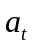 and 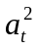

- GARCH
  - Reasoning
    - Research indicates state level data exhibits ARCH effects in other academic findings
    - Our results of serial correlation in squared residual series of the fit stationary series indicate ARCH effects in many states
  - Analysis
    - Test for ARCH effects using Box Ljung, with appropriate DF adjustment
    - Entertain parsimonious mean equation, with a GARCH (r≤2, s≤2) framework
  - Model Fit
    - Using garchOxFit package in R (joint estimation)
    - Make initial distributional assumption of standard normal for innovation series
    - State parameters, standard errors, t-statistics, and innovation distribution used
    - Discard insignificant mean/vol equation parameters
  - Box-Ljung test for model adequacy

- Long Term Dependence
  - Reasoning
    - Long term dependence may be evident in housing price processes on the basis of research findings and observed empirical evidence
    - Inadequacy of GARCH models, and other linear models lead to a further investigation of fractionally integrated models
  - Test for LTD
    - Packages used for testing include, but not limited to, fArma, fracdiff in R
    - Hurst parameter (H) ∈ (1/2 , 1)
    - Fractional differencing parameter (d) ∈ (0 , 1/2)
      - If ARFIMA(p,d,q) weakly stationary, and d∈(0 , 1/2), then LTD
      - Re-estimate p & q to get better confidence of weak stationarity
    - ACF behavior of first differenced series
    - Qualitative observation of structural breaks in first-diff. series
  - Model fitting (GPH d-parameter estimation)
  - Box-Ljung test for model adequacy

- Simulation
  - Observing the tail behavior from the simulated results to ensure model adequacy
  - Checking ACF/PACF of sim vs. orig can help check model adequacy

- Forecasting
  - Forecasts that shows different forecasted values for different models, along with confidence interval estimation

- Correlation Structure
  - Reasoning
    - Some linear combination of states, particularly with some geographical or other segmentation, may exhibit a unit root, and together may exhibit a unit-root (co-integrated)
    - Some long term dependence may be explained-away by combinations of states
    - An ultimate goal of VARMAX model which describes the most general housing price process is desired
Fitted Equations: Wyoming – ARMA

y_{t} = 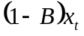
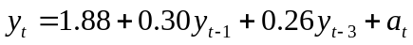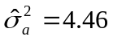

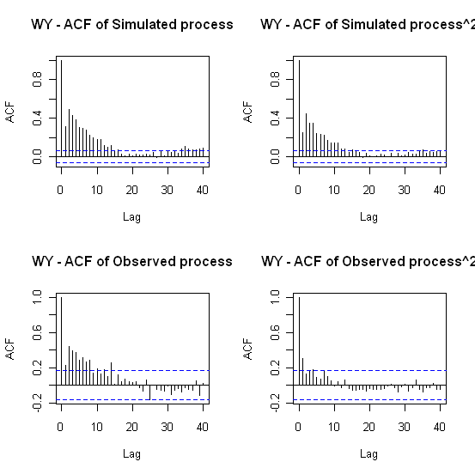

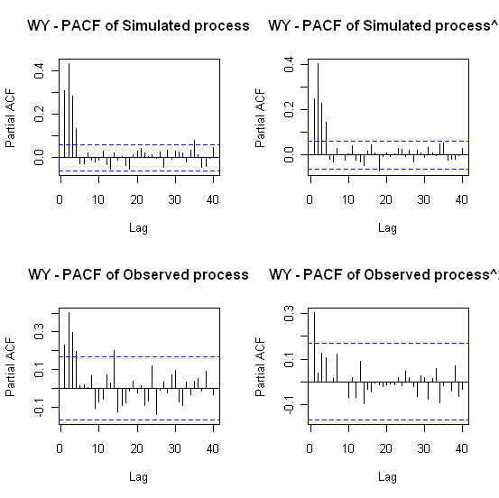

(n=1000; 100 simulations; burn-in period = 0.2*n)
Fitted Equations: New Mexico – GARCH

y_{t} =

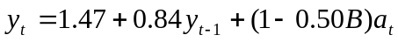

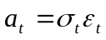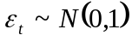

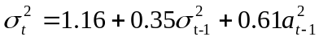

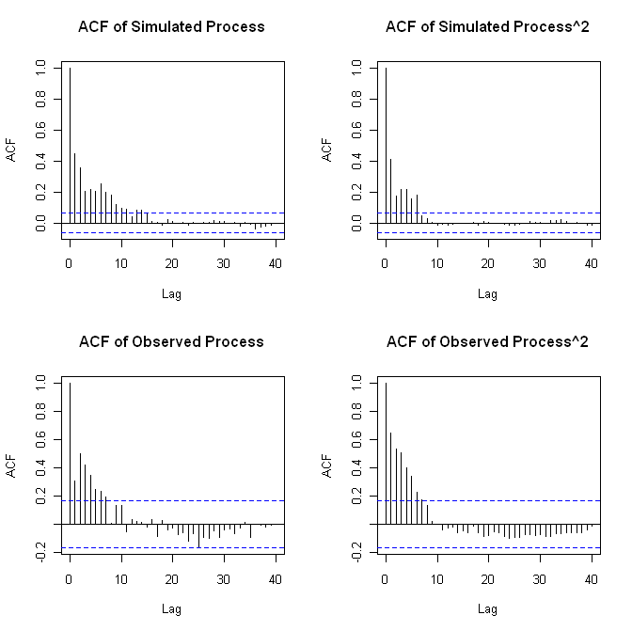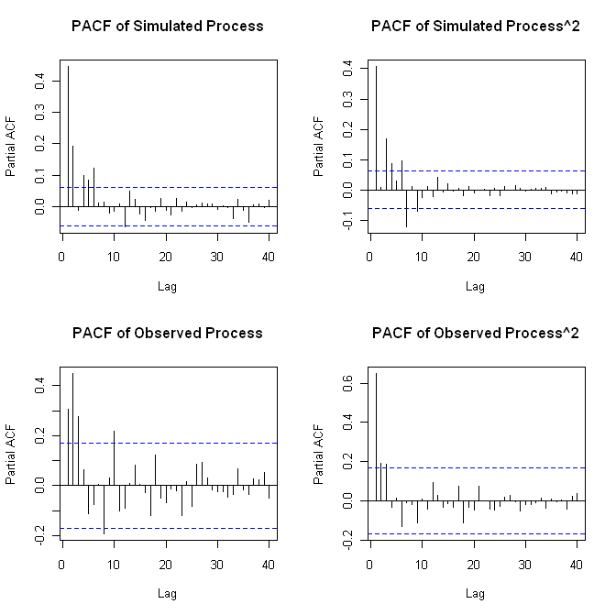
(n=1000; 100 simulations; burn-in period = 0.2*n)

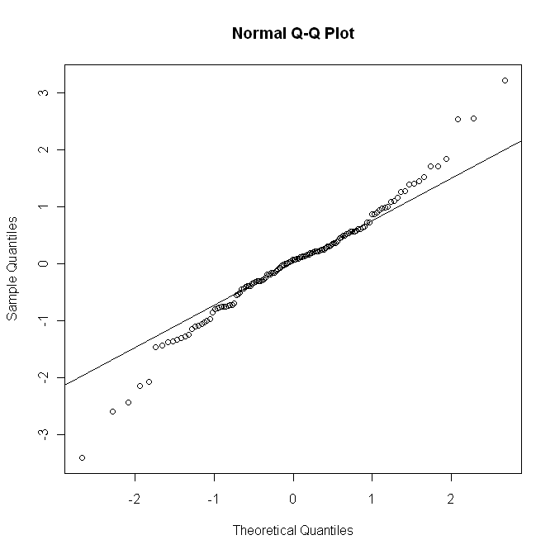
Fitted Equations: Kentucky – ARFIMA

y_{t} =

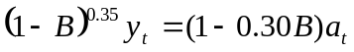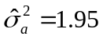

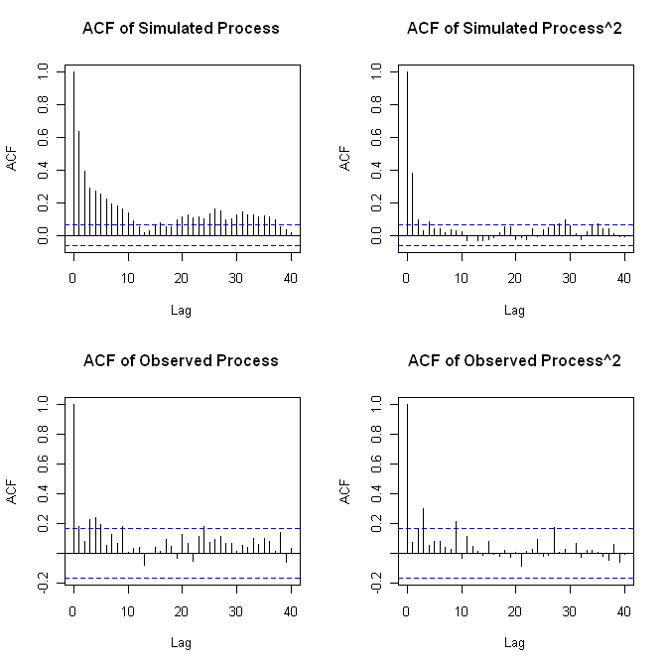

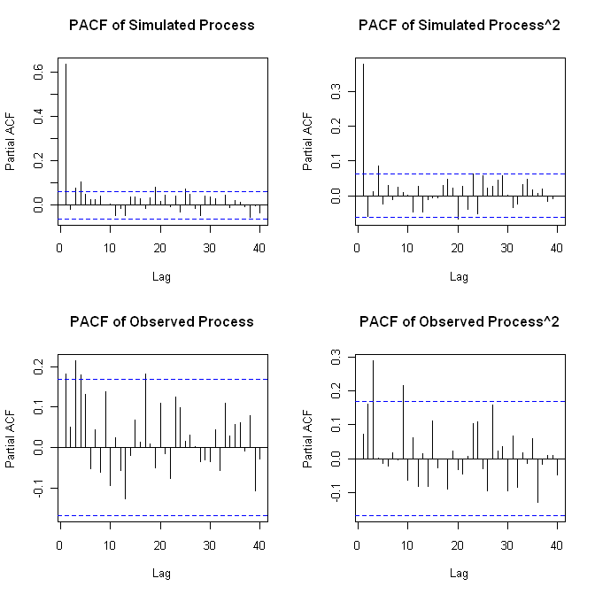

(n=1000; 100 simulations; burn-in period = 0.2*n)
Fractional Differencing Test on Nile River Data

Beran Results Reproduced Results
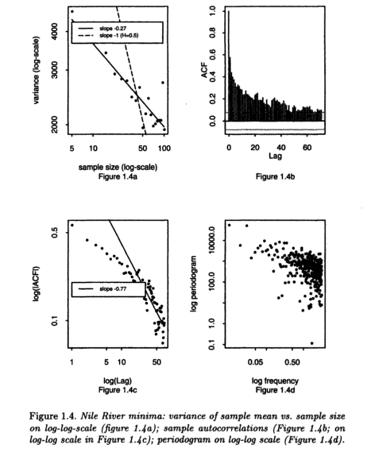
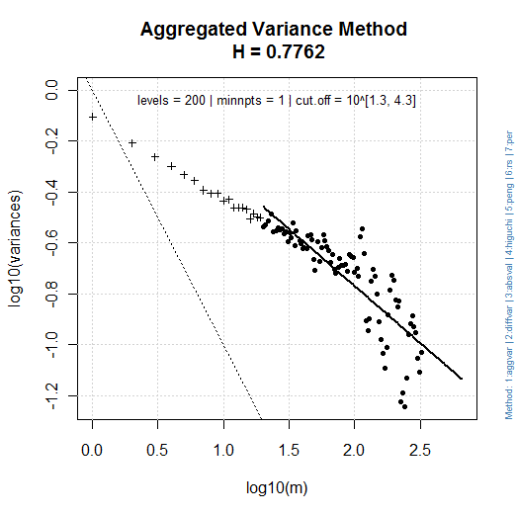 | 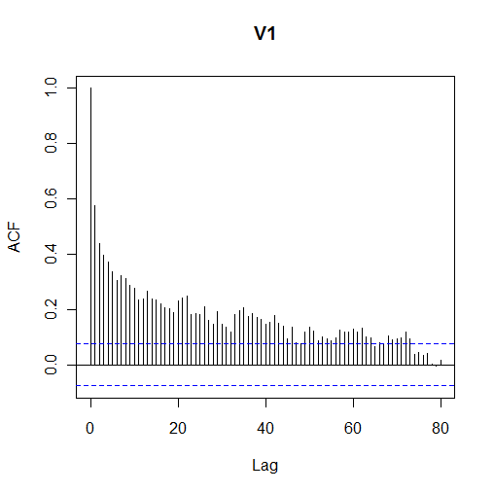
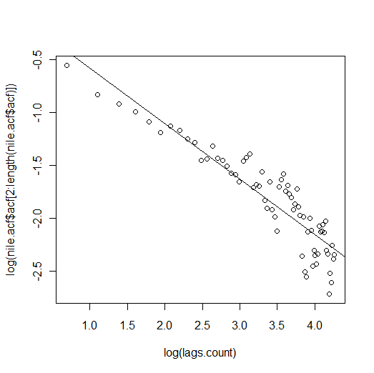 | 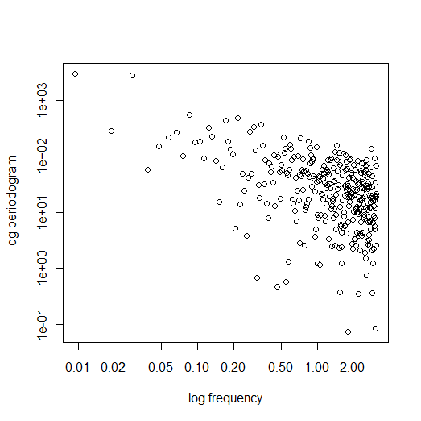
d Parameter Estimation

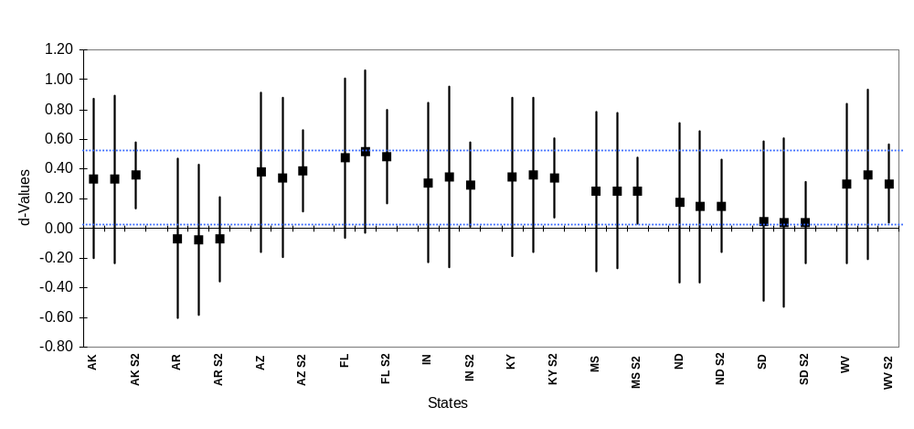

“State” – Observed Results
“State” S1 – Simulation Results with n = 100
“State” S2 – Simulation Results with n = 1,000
Next Steps

- Current Models
  - Refine current models
  - Forecasting
  - Correlation structure
  - Model consolidation
- Future Models
  - Incorporate new data
    - Case-Schiller HPI
    - MSA-level data
  - Incorporate external regressors
    - Econometric mortgage data
    - Treasury data
  - Modeling volatility
    - Volatility as 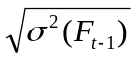
    - Suggestions for LTD in volatility
- Applications
  - Trading
  - Comprehensive multivariate model

